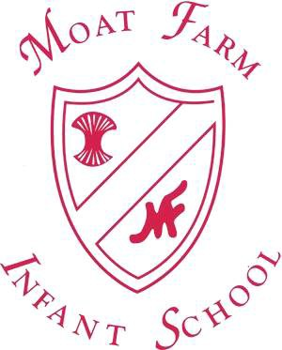
How can you help at home?
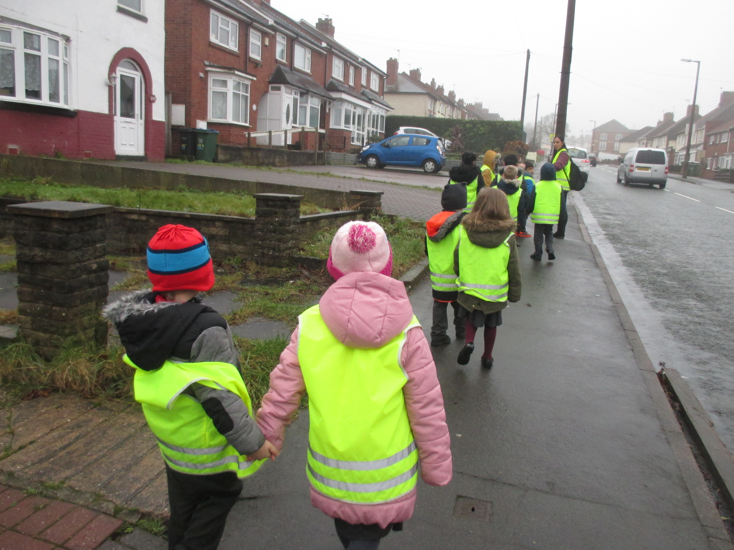
Moat Farm Infant School
Geography
Information Leaflet for
Parents and Carers

Geography is all around us! We can create learning experiences day to day about Geography by;
- Identifying physical and human features when walking in your local area.
- Talking about likes/dislikes and ways you can improve a place you have been.
- Sharing maps with children when you are walking, on car journeys or on holiday.
- Draw a map of the places you have been.
- Compare places, for example; how is our local area the same/different to Spain?
- Talk about the importance of recycling and taking care of the environment.

There are also lots of great websites to help us learn about Geography;

https://www.google.co.uk/maps/
http://www.bbc.co.uk/schools/teachers/keystage_1/games/geography1.shtml
http://www.topmarks.co.uk/Interactive.aspx?cat=90
http://www.topmarks.co.uk/Search.aspx?Subject=12&AgeGroup=2
http://www.atschool.co.uk/keystage1-ks1/geography.asp

Please contact the following person for any additional information:

Lucy Taylor Geography Coordinator Moat Farm Infant School

Brookfields Road Oldbury
West Midlands B68 9QR
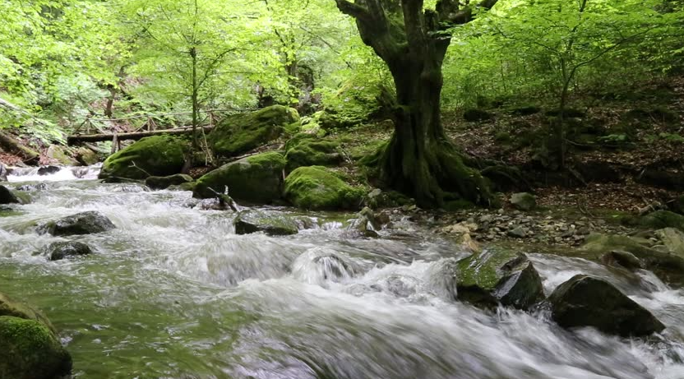


What will our children learn in Geography at Moat Farm Infant School?

Geography at Moat Farm
Infant School

Knowledge, Skills and Understanding
Through Geography, children study people, places and environments throughout the world. It develops an understanding of the human and natural world, maps, and a range of investigative and problem solving skills. Through geographical enquiry children can learn to evaluate the world around them. It offers children the opportunity to engage in field work activities and to consider how their own actions may have an impact on the environment.

The children learn to use maps to locate features such as cities, countries, mountain ranges, rivers, seas and oceans. It also helps with direction. They use other sources including atlases, photos and the internet to explore the environment of the places they study. We also celebrate different cultures and countries during Multi Cultural week.

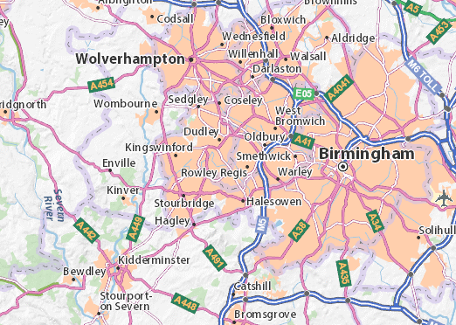

Early Years Foundation Stage –
In Nursery and Reception, understanding the world involves guiding children to make sense of their physical world and their community through opportunities to explore, observe and find out about people, places, technology and the environment.

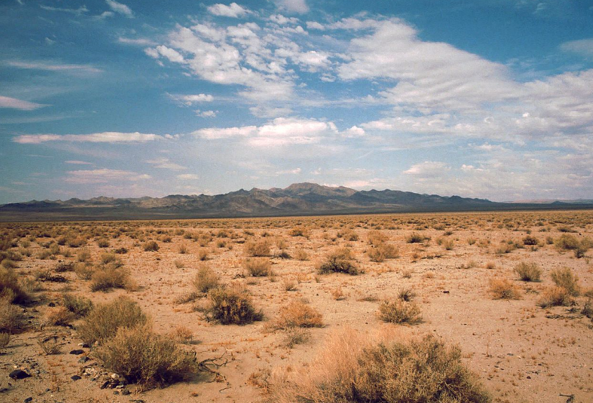

Key stage 1 –
During Key Stage 1 our children investigate their local area and a contrasting area in the United Kingdom or abroad, finding out about the environment in both areas and the people who live there. They also begin to learn about the wider world. They carry out geographical enquiry inside and outside the classroom. In doing this they ask geographical questions about people, places and environments, and use geographical skills and resources such as maps and photographs.

Geographical Enquiry and Skills
Our children will be taught to:
- Use geographical language when using globes, maps and ariel photographs.
- Express own views about places, environments and their own local area.
- Use simple compass directions.

Knowledge and Understanding of Places
Our children will be taught to:
- Understand human and physical features in their local area.
- Name and locate the world’s seven continents and five oceans.
- Name and locate the four countries in the United Kingdom and their capital cities.

Knowledge and Understanding of Human and Physical geography
Our children will be taught to:
- Identify seasons and weather patterns.
- Locate hot and cold countries around the world.

